CMSC 204

Huffman Lab

1. Create a Huffman Tree and generate the codes for each character of the following input:

create a huffman tree

For consistency:

1. If same frequency – put in priority queue alphabetically; put space before other characters of the same frequency
2. Add subtrees to end of group with same priority
3. Lower number has higher priority (goes to front)

a = 3

f = 2

h = 1

m = 1

n = 1

r = 2

t = 2

u = 1

c = 1

e = 4

= 3

Now encode “create a huffman tree”

0100000111101001111100101100010111001101110101101010111100001000111111

1. Based on the following Huffman tree and binary sequence, what is the text

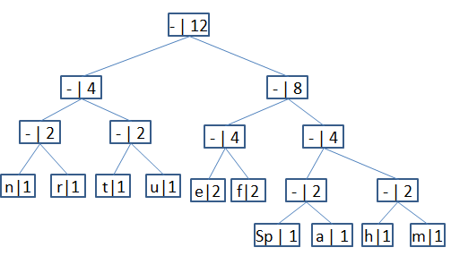

1110|011|101|101|1111|1101|000|1100|010|001|100|100

H U F F M A N - T R E E